**Concept/ Idea**

*Granular sampler instrument*

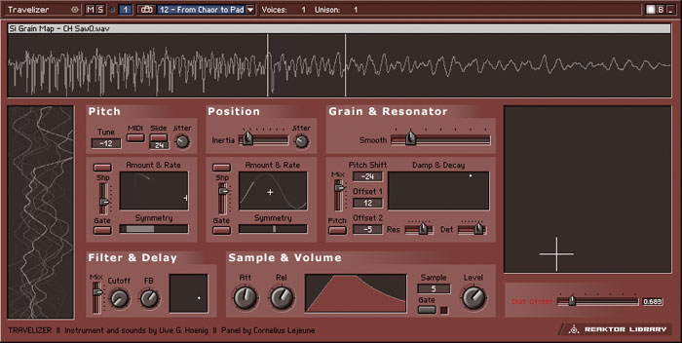In the last year I have enjoyed experimenting with granular synthesis on programs such as Absynth and Reaktor. I was made aware of granular concepts and sounds through artists such as Autechre, Aphex Twin, Venetian Snares and Apparat (<http://www.youtube.com/watch?v=PVdKacGcRQs>). After experimenting with granular synthesis mostly in Reaktor, I began creating sounds to use in my own music. [1] A feature that I particularly enjoy is being able to sculpt sound using unconventional controls such as grain position, length, density, smooth and speed and then re-pitching the sound across a midi keyboard. For me this opened up an exciting new range of sound possibilities and textures as I find the process of sculpting these sounds by ear very appealing and different compared to creating sounds on a subtractive synthesiser for example.

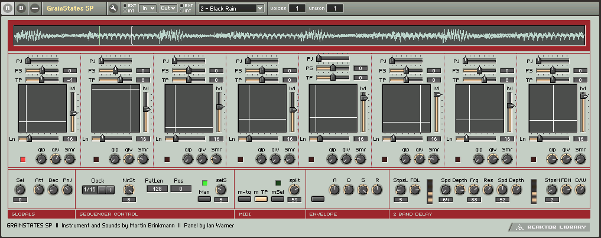There are many things that I like about the Reaktor instrument ‘Traveliser’ and ‘Grainstates’ but there are functions of both that I am not particularly interested in using, and that while one has the ability to do one thing, the other does not. I’ve realised that while these programs have the ability to create many semi-random unpredictable sounds and textures, it took a lot of careful tweaking to produce the controlled musical sounds that I prefer. [2] Also I didn’t feel that they were very useable in a live/performance situation. For these reasons I have decided to use granular synthesis as a starting point for my system. After research, I am still not aware of any programs that are dedicated to creating the sounds that I have in mind which is why I am interested in the idea of making a system that is quite unique and personal to me, that I will want to use myself in music sound creation and performance.

Traveliser

**So what do I want my system to do?**

It will need to be able to store and read pre-recorded samples/grainclouds as well as continuously reading incoming audio signals such as in the ‘Grainstates FX’ plug in.

It will need a variety of parameter controls such as grain position, grain length, smooth (grain fade in/out time) and the ability to scrub through the audio. Other useful features could include a position control which automatically scrubs through the grain cloud with controls to specify speed and amount. Another useful feature would be a ‘Hold’ or ‘Freeze’ button to catch and pause the playhead, this will provide a ‘glitchy’ effect whenever used.

Grainstates

It will need to be able to re-pitch the sampled sound using a midi keyboard controller. Initially I will be using a “kslider” object with an “mtof” (midi to frequency) object to change the pitch of the playback on screen but I will also need it to work with hardware midi keyboard controllers. I can use the “notein” object to assign midi controllers (see p5 for more detail on all of these objects). Ideally I would also like to have other functions assigned to buttons, dials and faders on the midi keyboard controller. Incorporating other hardware controllers such as midi pedals to control parameters and buttons for example ‘speed’ and ‘freeze’ function, would improve the usability.

Adding some random elements to the system will help to add spontaneous textures for improvised music and soundscapes. Both ‘Traveliser’ and ‘Grainstates’ use a jitter control which has been applied separately to pitch and position. I would like to create a pan jitter effect; as I’m not aware of an object that already does this, I could create my own using the “random” object. A delay effect would also be useful for emphasising the granular sound I have in mind particularly if it was synchronized with the pan jitter.

Volume Envelope for the sculpting of sounds, an ADSR volume envelope would help to increase the amount of control that the user has over the sound, making it a more playable instrument.

Max/MSP has a presentation mode which allows you to select parts of your patch such as buttons, faders and any objects that you need to use and present them to the user in a visually easy to understand way. This means that things you don’t need to see such as patch chords and unused objects can be hidden so that they do not clutter the screen and confuse the user. In presentation mode you can move, rename and resize objects around the screen without changing they’re function. The “panel” object can be used to create simple backgrounds for presentation. Panels can be sent messages to change size and colour as well as being used with a “ubutton” object to make buttons. You can also control features of panels from the inspector, use “fpic” to load your own pictures as backgrounds, buttons or cursors.

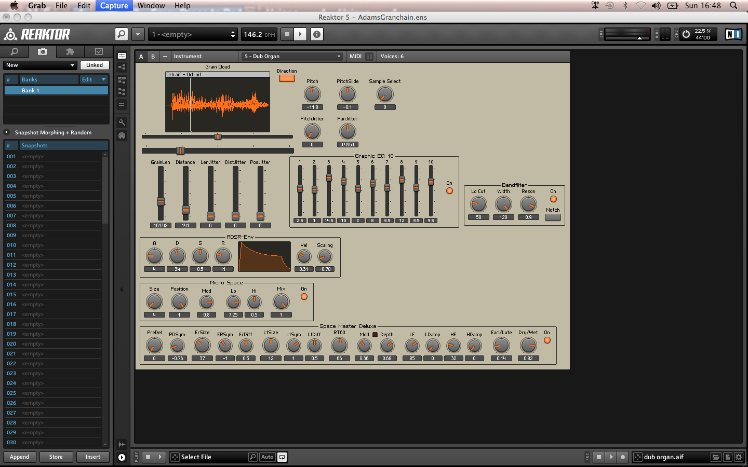My system needs a straightforward GUI with the ability to create, store and recall presets. This could either be in the form of the “preset” object or better still a selectable list so that presets can be given names and descriptions. The interface will be divided into different coloured/bordered sections. One section will contain the controls for the loading and selection of files. Another section will be the “waveform~” section where you will have a visual selectable display of the soundwave of the sample. Another section will contain the grain modification controls such as speed, pitch and length. Another section will be the volume envelope and effects section which will contain controls for all relevant parameters such as attack, decay, sustain, release, delay time, amount, feedback. XY pads have been used by Traveliser and Grainstates to control various parameters such as speed, length, position and pitch and they work very well so I will probably experiment with these. If they make my system easier for the user then I will use them in my final design.

The GUI of a granular sampler I built in Reaktor

The system should be usable to almost anyone interested in experimenting with granular synthesis. Because it can hold live audio and use pre-recorded samples it has the possibilities to be used by DJ’s, producers and performers in a variety of ways. The use of midi pedals would greatly add to the flow of the system as a performance tool making it part of an experimental live setup for solo artist, band or DJ.

**Prototype**

For my prototype I want to be able to load samples into a buffer as well as record live audio into a buffer, I then want to be able to re-pitch it on a midi keyboard. The prototype will feature buttons associated to the “waveform~” object to select cursor as well as instructions for keyboard commands. The prototype should have a simple delay effect. It should also have a pan feature possibly using the “pan2” object. The prototype should have a volume envelope as well as a smooth function to counter clicks between grains.

The GUI should have a visual waveform such as the “waveform” object that selections can be made to using the mouse and keyboard functions. These selections will be for selection length and position. It will also have buttons to select different cursors such as scrub, draw, move from a sub-patch. It will also contain message buttons to replace the file, crop and undo and well as level meters and faders and control for the smoothing function.

**How will I further my project? How could it progress in the future?**

As the main focus of my project is to make a playable granular sampler instrument, I would like to develop it further by adding granular inspired effects such as a glitch/stutter, delay. Other effects that I think would be well suited could be a resonator. I would like to develop more control over the sound by including a filter. Ultimately it could be made into a plug in instrument for ease of use with a sequencer.

**Timeline**

*December* – December will be spent making small patches that perform various functions that I have identified as being needed. This will include things such as keyboard triggers, a few different types of simple envelopes for grain smoothing. I will aim to assemble all of the things needed to create a basic version of my prototype.

1st week – Begin by making some small patches. By the end of the week I should be able to load a sample into a buffer, view it as a wave form, loop, playback and select chucks of audio/grains as well as a crop and undo function.

2nd week – By the end of the week I should be able to record live into a buffer. I will also build a simple envelope to smooth off clicks (see p5 for more information).

3rd week – Include an on screen midi keyboard and by the end of the week have a midi controller working.

4th week – Try out associated externals/abstractions and evaluate and compare to groove/play objects (see p6 for a list and explanation of these externals/abstractions.

*January -*

1st week – Make a volume envelope possibly by using the adsr~ object.

2nd week – Consider and add two simple effects; delay and pan.

3rd week – Consolidate work and make final changes to prototype

4th week – Design GUI for my system using presentation mode

31st Jan – Prototype Deadline

*February* – throughout February I will be making improvements based on the response to my prototype as well as further developing, improving and expanding on my initial ideas further.

1st week – Look at using the global transport and how this might help me to have the playhead automatically scrub through the sample selection.

2nd week – Work on the sample loading and storing function. Try to develop a more sophisticated system that lets you load and select multiple samples.

3rd week – Develop stutter/glitch effect.

4th week – Consolidate work in preparation of March

*March* – The state of my system by March will determine what needs to be done. In general I will look to push my system further, possibly by developing new elements such as effects, polyphony, other hardware integration, randomisation, Ableton/Max for live or expanding on initial ideas such as more sophisticated delay and panning.

1st week – Hardware controller usability; assign various parameters to midi hardware controller and consider what other controller options are possible.

2nd week – Get my system working with Ableton/Max for live

3rd week – Test and evaluate system

4th week – Final improvements based on testing and evaluation

*April* – will be used primarily for final improvements to the system as well as for the creation of the demonstration track and written project documentation.

1st week – Finish design of system

2nd week – Work on GUI, by the end of the week all improvements to GUI should be finished.

3rd week – Make demonstration track

4th week – Work on the written documentation. By the end of this week any problems to do with my system should be resolved; no changes should be made to the system after this unless a new problem is found. Same goes for the GUI, demonstration track and written documentation.

*May* – by May I should be ready to consolidate by project in time for the final deadline.

1st May – Finish consolidating project

9th May – Final Deadline

**Considerations based on my research and list of useful objects**

A problem commonly associated with granular synthesis is clicking at the beginning/end of grains. However in varying amounts this can be a desired sound of granular synthesis so I do not want to simply eliminate in completely. Therefore I want to include a ‘Smoothing’ control so that you can set the amount of smoothing between each grain. This is often achieved by using an envelope (Attack/Decay) such as in ‘Traveliser’. I have discovered a few different ways of doing this in Max/MSP and I’m sure there are many more that I am yet to realise.

To develop this as a live performance tool, it would benefit from being compatible with a sequencer such as Ableton live. This will be possible through using ReWire or Max for Live. “You can use Max as a ReWire client and route audio from Max into another application (such as Ableton Live...) using ad_rewire, a special audio driver” (<http://www.cycling74.com/docs/max5/vignettes/core/rewire.html>). The ReWire driver can be turned on by selecting ad_rewire from the DSP status menu. There are three associated objects; “hostcontrol~”, “hostphasor~” and “hostsync~” used in Max to help control synchronisation and transport messages such as start, stop and tempo. Using Max for live would be the easiest method as it lets you seamlessly use Max inside Ableton, but I will probably use ReWire until I get Max for Live.

Using a cycle~ object – if driving the cycle object by phase alone (e.g. phasor~) and manipulating the output (decreasing range) you can create a simple amplitude envelope.

trapezoid~ object may help me with making the smoothing function

adsr~ this object can be used to make a volume envelope

rslider can be used to select different ranges and move through them so this could be used for selecting parts of the sample and scrubbing through grains.

waveform~ is an object that will allow me to view and edit the contents of a buffer. It is used in a similar way to the rslider.

preset object stores presets which will help make the instrument more playable

groove~ and play~ these objects allow me to reference, communicate and loop with the buffer

phasor~, record~, ezadc~

buffer~ object will be used for loading and storing samples and capturing live audio

pan2 object is a stereo panner that I might use

kslider I can use the “kslider” to re-pitch my samples by placing an “mtof” (midi to frequency) object between it and the groove object

scale object will allow me to scale ranges

hostcontrol~, hostphasor~ and hostsync~ objects communicate with ReWire to give transport and synchronisation control.

**Research sources**

Roads, C. (2004) ‘Microsound’. This book contains explanations of the fundamental concepts involved in granular synthesis, the history of microsound from ancient philosophies right through to modern digital granular synthesis techniques and even considers the aesthetics of microsound composition.

Max/MSP abstractions and externals – From my research I have found particular abstractions/externals commonly used and built specifically for granular synthesis in Max. I need to now use and understand them to further my progress.

mdeGranular~ was made by Michael Edwards and can be found at <http://www.michael-edwards.org/software/mdegranular/mdegranular.html/> “A Max/MSP external object for multi-channel, multi-voice, multi-transposition granular synthesis”.

Granular Toolkit v1.49 by Nathan Wolek is a set of externals and abstractions which utilise several granular synthesis concepts such as pitch shifting, spatializing, clouds, chord production and looping. According to Nathan Wolek, the reason he made this toolkit was because Max/MSP does not include sufficient externals to meet the efficiency and flexibility needs for creating such effects. <http://www.lowkeydigitalstudio.com/2007/03/granular-toolkit-v1-49/>

GrainTools by Marcel Wierckx is a set of abstractions for performing various granular synthesis tricks. <http://www.lownorth.nl/software/downloads/graintools.zip>

Various Reaktor instruments involving granular synthesis such as ‘Grainstates’ and ‘Traveliser’ as well as user made ensembles. This helped me to see different methods of making granular synthesisers in Reaktor and helped me decide on what parameters and elements were most important to me when building my own which is transferrable to Max/MSP.

Youtube channel ‘Joelisrich’ <http://www.youtube.com/user/joelisrich> . This youtube channel contains some simple videos that helped me to get started.

Youtube tutorials and Max/MSP tutorials and help files

<http://www.youtube.com/watch?v=Ltyo_KB8J94> (Groove object)

<http://www.youtube.com/watch?v=Z-1nRI4eaKc> (Granular)

<http://www.youtube.com/watch?v=LoA0a-zFC8c> (Delay)

Information and advice for using ReWire in Max/MSP; <http://www.cycling74.com/docs/max5/vignettes/core/rewire.html>

1. Track 1 – audio example of granular synthesis being used on a track I made last year
2. Tracks 2, 3, 4, and 5 – audio examples of some of the types of sounds I favour. These were recorded using a granular sampler instrument I made in Reaktor in October. Building this instrument in Reaktor first helped me to understand some of the basic principles behind granular synthesis. The Reaktor ensemble is included with the sound clips.